


Headless
(OCAPI/SCAPI/PWA-Kit) Configuration guide

Version: 5.1.0
Published date: May 2026
Copyright © 2026 by ESW. All rights reserved. Information contained herein is subject to change without notice.

SFCC - ESW Cartridge
+
Contents
1 Headless cartridge 3
2 Headless related configurations 3
3 Headless cartridge configuration 5
3.1 Shared configurations for SCAPI and OCAPI 5
3.2 Headless SCAPI token generation 5
3.3 Headless OCAPI/SCAPI configuration 6
3.4 Add Shop API Resources 6
3.5 Cartridge setup to integrate with OOB Salesforce PWA-Kit 7
4 SCAPI Custom Endpoint 7
5 Endpoints (Hooks) Customizations 8
6 OCAPI/SCAPI Request Parameters 11
6.1 OCAPI parameters 11
6.2 SCAPI parameters 11
7 Hook Response Mapping 11
7.1 Product 11
7.2 Basket 12
7.3 Order 12
8 ESW Order Placement 12
8.1 Basket Creation Request Payload 13
8.2 Order Confirmation 14
8.3 Generic Price Conversion Endpoint 14
8.4 Post order actions 15
8.5 ESW Headless Cart Rebuild from Order 15

Headless cartridge
The headless cartridge supports both OCAPI and SCAPI architectures by leveraging a shared set of hooks. Because it does not override any authentication mechanisms, it works seamlessly with both OCAPI and SCAPI endpoints.
For PWA Kit implementations, a separate, Salesforce PWA Kit–compatible attribute mapping is also available. This document explains how to configure the cartridge and the associated mappings.
There is no specific configuration to use with OCAPI/SCAPI, however if you want to use this with OOB salesforce PWA-kit then “ESW Is PWA Kit Mapping Enabled” needs to be set to “YES”.
Note: int_eshopworld_headless is an overlay cartridge that includes all OCAPI/SCAPI customizations. You can duplicate the customizations in your cartridge by including the function calls in your hook call files (hooks.json).

Headless related configurations
Below are the configurations needs to be set to use headless cartridge after configuring other relevant ESW related configurations. These configurations can be found in “Merchant Tools > Site Preferences > Custom Site Preference Groups > ESW Headless Integration Configuration”. 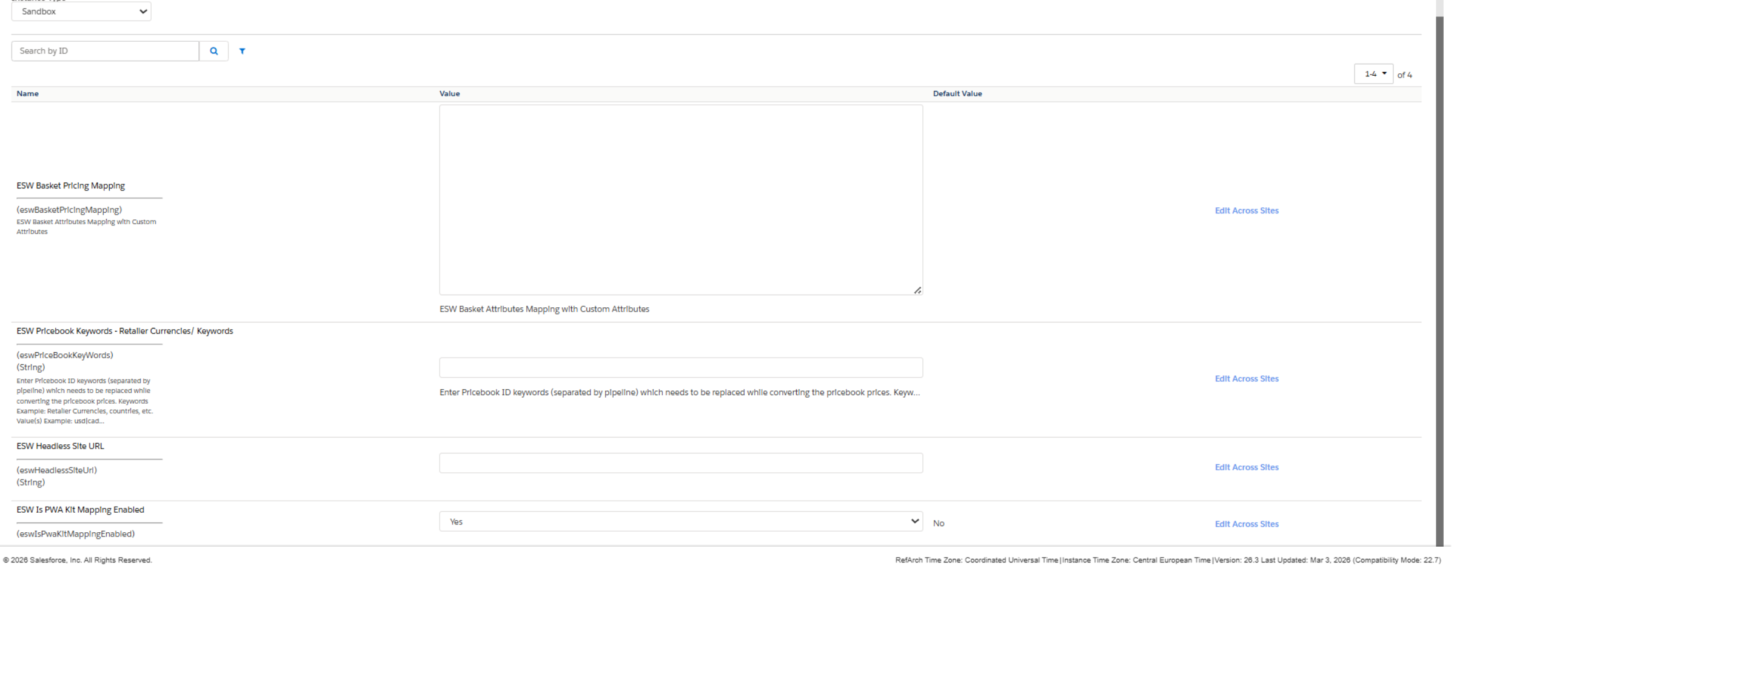
ESW Headless Integration Configuration Custom Preferences:
- ESW Basket Pricing Mapping: This preference contains the mapping between the Basket API object attributes and ESW basket custom attributes. The following code sample shows the mapping:
{
"c_estimatedCharges": "eswEstimatedCharges",
"c_cartSubtotal": "eswCartSubTotal",
"c_total-discount": "eswTotalDiscount",
"productLineItems": {
"c_regular-price": "eswRegularPrice",
"c_sale-price": "eswSalePrice"
}
}
The following table lists the Basket API object attributes and ESW-specific basket custom attributes used in the mapping. The cartridge takes the value of basket-related attributes, converts these values to shopper prices, and stores the converted price in the ESW basket custom attributes.
Basket API object attributes | ESW basket custom attributes
c_estimatedCharges | eswEstimatedCharges
c_cartSubtotal | eswCartSubTotal
c_total-discount | eswTotalDiscount
c_regular-price | eswRegularPrice
c_sale-price | eswSalePrice
c_available_shipping_methods | eswOverrideShipping
- ESW Pricebook Keywords - Retailer Currencies/ Keywords: This preference holds the price book ID keywords (separated by pipeline) that need to be replaced when converting the price book prices.
Keywords Example: Retailer Currencies, countries, and so on.
Value Example: usd|cad|gbp|abc
Use Case
When converting prices, ESW takes the prices from the retailer’s base currency price book and converts these prices to shopper currency prices. If the retailer's base currency price book ID is 'usd-list-prices'/'usd-sale-prices', ESW converts the prices and puts the converted price values against the IDs with 'eswPriceOf-' as the suffix. This changes the ID from 'usd-list-prices'/ 'usd-sale-prices' to 'eswPriceOf-usd-list-prices'/ 'eswPriceOf-usd-sale-prices' in the response.
However, as this naming convention could be confusing, the keywords in the price book IDs can be changed to a keyword called 'base'. This means that if the brand name is 'abc' and the price book ID is 'abc-list-prices', the ID will be 'eswPriceOf-base-list-prices' in the response.
- ESW Headless Site URL: This is Site URL of retailer’s Headless domain which will be concatenated with LTI script path to redirect the shopper to embedded checkout. The preference is required only for embedded checkout.
- ESW Is PWA Kit Mapping Enabled: Enabling (Yes) this preference will allow to integrate headless cartridge with OOB pwa-kit cartrtidge, it will return mapping suitable for pwa-kit storefront.

Headless cartridge configuration
To configure headless for Non PWA-kit storefront there are few configurations require to generate the client id. This is different for SCAPI and OCAPI.

Shared configurations for SCAPI and OCAPI
- Account Manager Setup: Log in to Commerce Cloud Account Manager and create a unique API Client ID for your headless application.
- Set Redirect URIs: Add necessary redirect URIs in the Client ID settings (critical for SLAS and OAuth flows).
- Identify Instance Details: Retrieve your Organization ID and Short Code, from Business Manager (Administration > Site Development > Salesforce Commerce API Settings).
- Business Manager Access: Ensure your Business Manager user has the "Administrator" or "API User" role to modify API settings
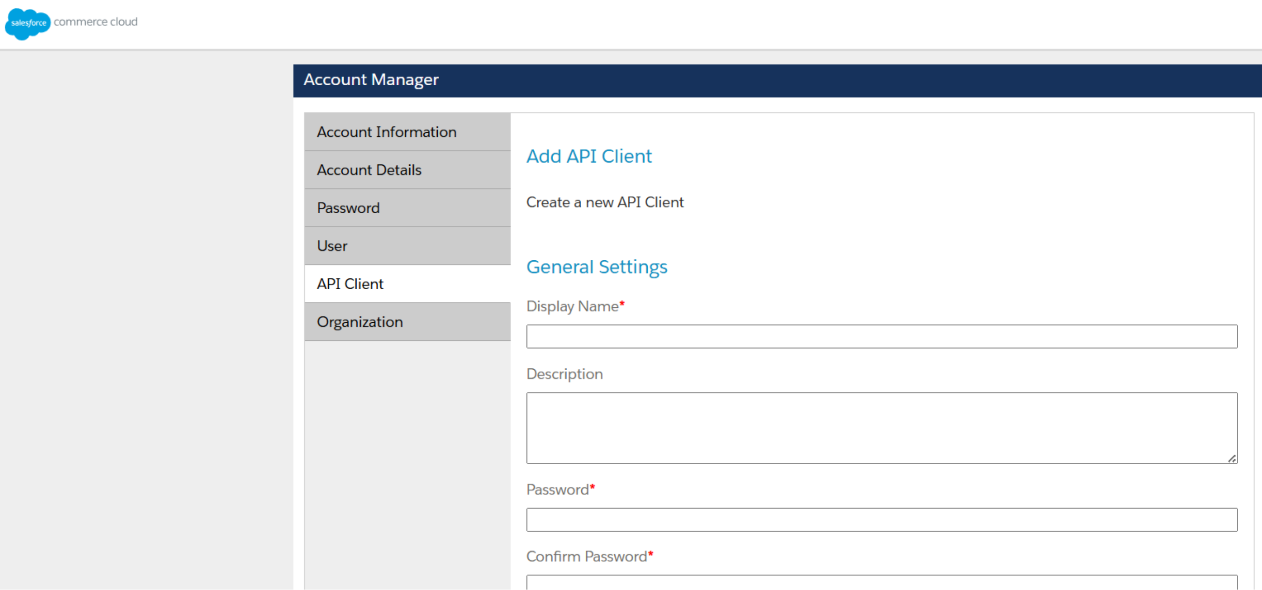

Headless SCAPI token generation
- SLAS Admin Setup: Access the Shopper Login and API Access Service (SLAS) Admin UI (https://{{shortCode}}.api.commercecloud.salesforce.com/shopper/auth-admin/v1/sso/login) and authorize your Account Manager Client ID.
- Create SLAS Client: Register a public or private client from SLAS UI.
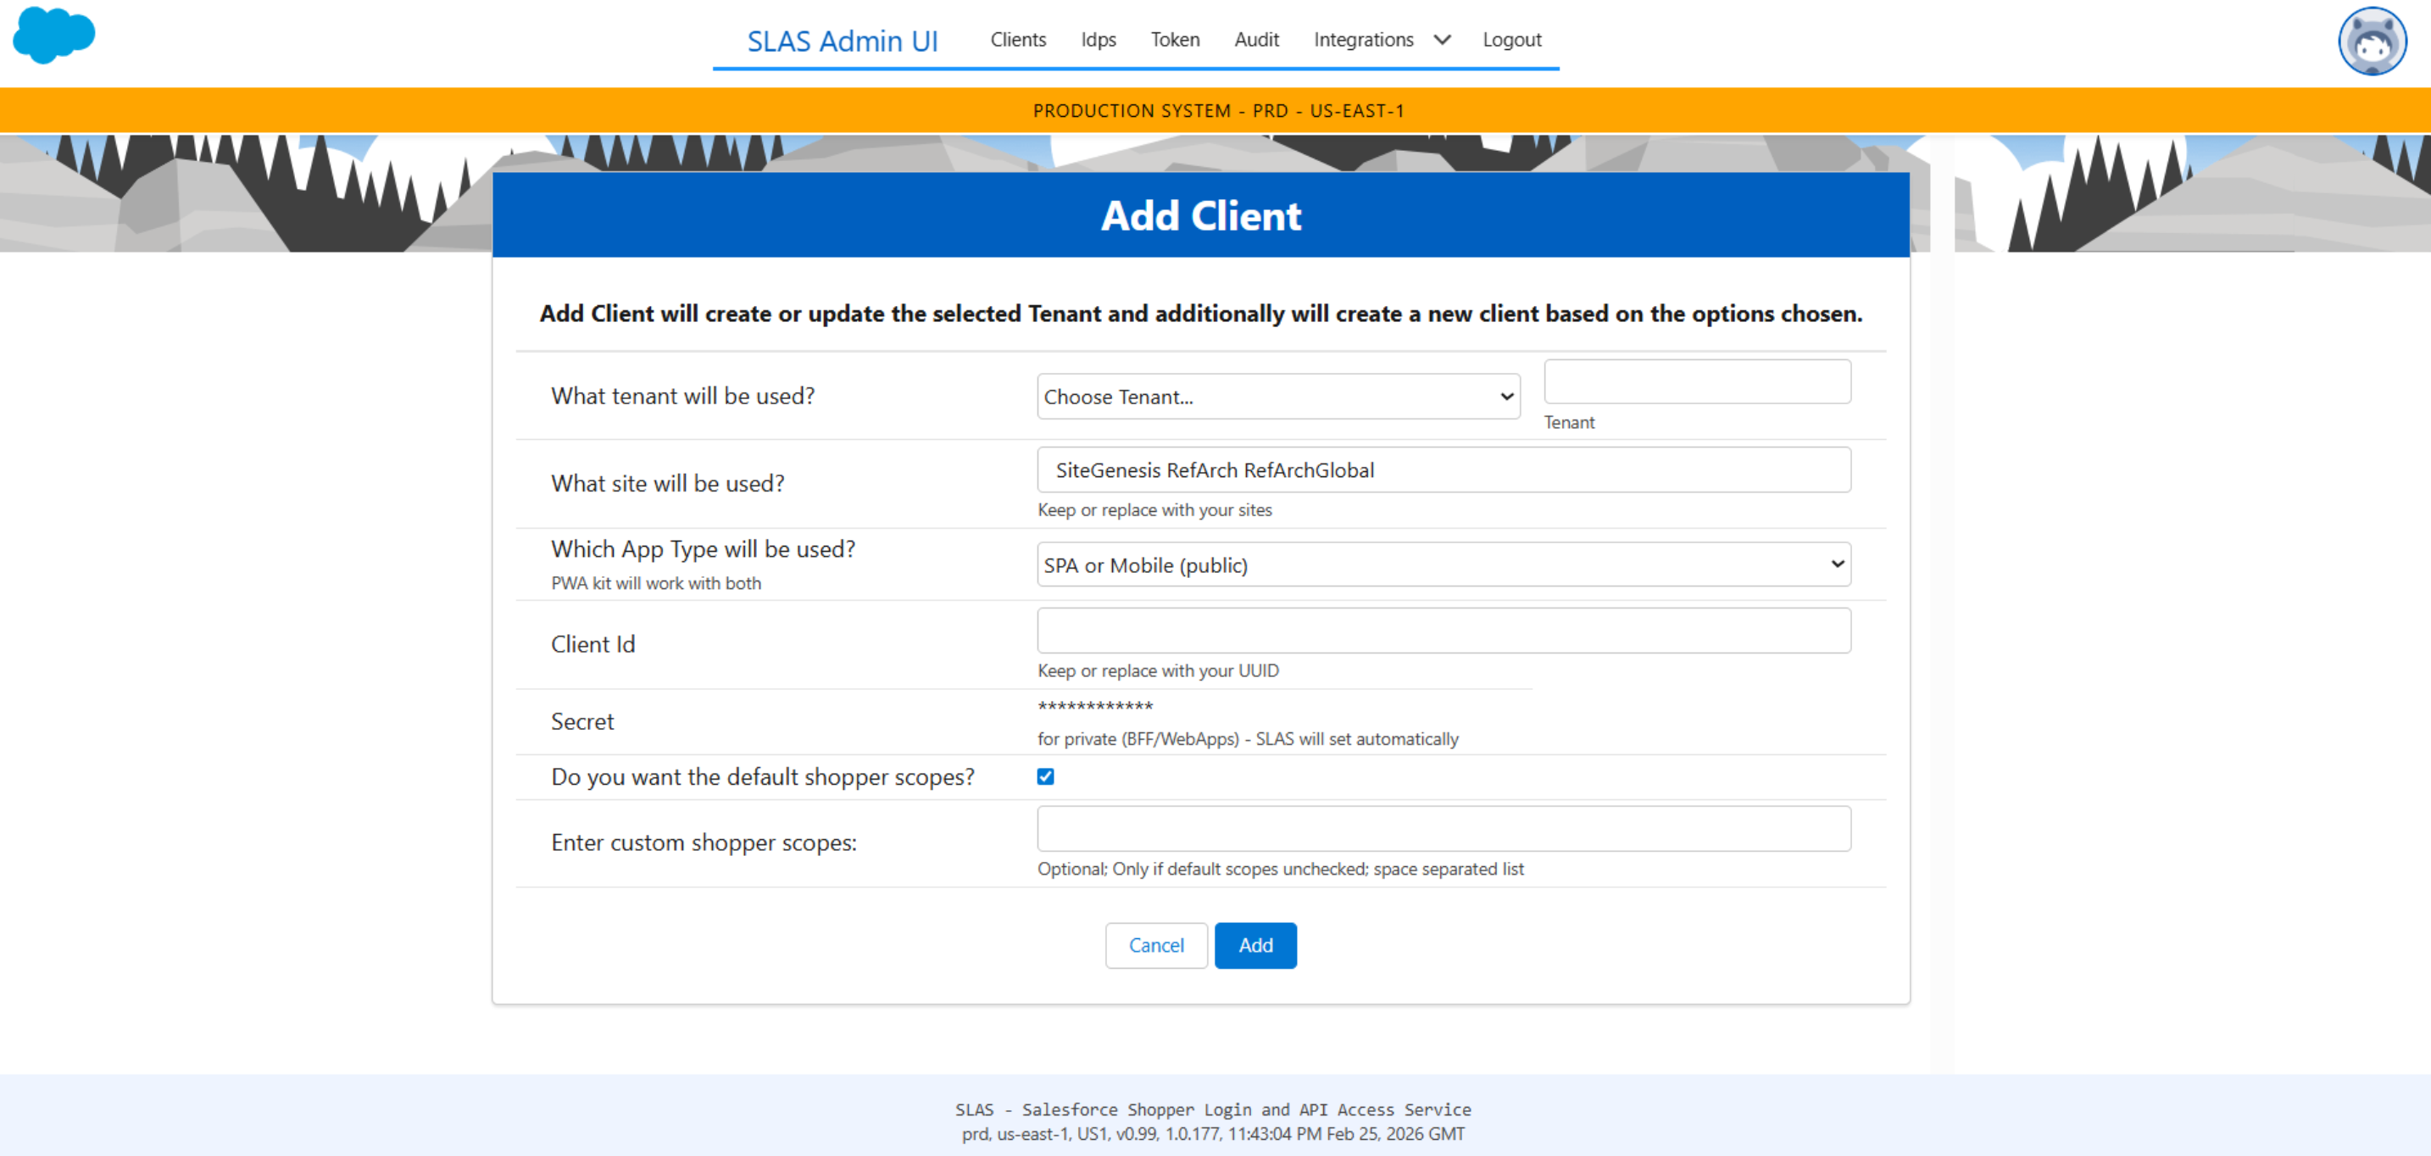
Note: Copy the generated token, we will use it later in “Administration > Site Development > Open Commerce API Settings” as client_id

Headless OCAPI/SCAPI configuration
This section describes how to configure Shop API resources under OCAPI settings. ESW recommends that you configure Shop API version 23.1 or later for optimum utilization of the cartridge.

Add Shop API Resources
For the cartridge to work, you must add Shop API resources to the cartridge.
To add resources:
- On the target site, go to Administration > Site Development > Open Commerce API Settings.
- From the Select type drop-down, select Shop.
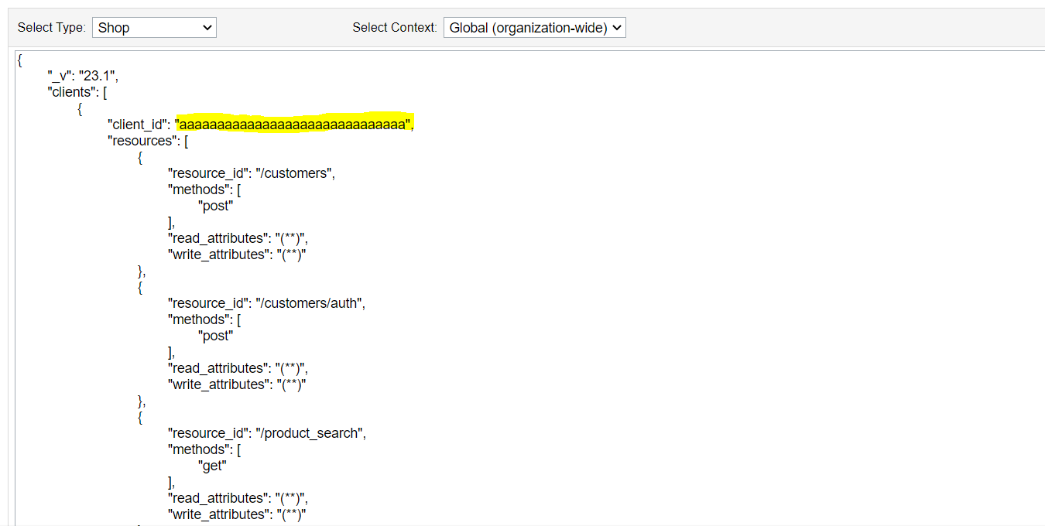
- From the Select Context drop-down, select the appropriate context, for example, Global (organization-wide) or site-specific.
- Enter the data API resources provided in the ocapi-configurations.json file in the documentation folder.
- Update the client_id with the one you generated from the Commerce Cloud Account Manager.
- Click Save.

Cartridge setup to integrate with OOB Salesforce PWA-Kit
To setup with PWA kit, please refer to the document eShopWorld_Cartridge_Pwa_Integration.docx

SCAPI Custom Endpoint
Following custom SCAPI endpoints are added
Endpoint | Purpose | Allowed parameters
/getBmConfigs | Returns filtered ESW BM config flags and shopper pricing config for selected country. | siteId (required), c_country (required, string)
/getSupportedCountries | Returns allowed country list based on shopper timezone. | siteId (required), c_eswShopperTimezone (required, string)
/getGeoIpAlert | Returns GeoIP comparison result for shopper country. | siteId (required), c_shopperCountry (required, string)
/getAbandonmentCart | Rebuilds basket data from last order context for abandonment flow. | siteId (required), c_eswClientLastOrderId (required, string)
/getEswTestContent | For Testing: Returns test content asset payload. | siteId (required)
/getRegisterCustomer | Builds login/registration redirect URL for customer based on order/cart id. | siteId (required), c_retailerCartId (required, string)
/getOrderNumber | Resolves and returns current order number for given input order reference. | siteId (required), c_orderNumber (required, string)

Endpoints (Hooks) Customizations
The following table lists the SFCC and OCAPI hook overrides implemented by the ESW Headless cartridge, along with their associated extension scripts and purpose.
Hook name | Extension script | Purpose of extension
dw.ocapi.shop.basket.afterPATCH | ./ocapi/shop/hooks/basketItemsUpdateResponse.js | Updates basket payload after basket PATCH.
dw.ocapi.shop.basket.afterPOST | ./ocapi/shop/hooks/basketHooks.js | Finalizes basket response after basket creation.
dw.ocapi.shop.basket.beforePATCH | ./ocapi/shop/hooks/basketItemsModifyResponse.js; ./ocapi/shop/hooks/basketHooks.js | Prepares and validates basket data before PATCH.
dw.ocapi.shop.basket.beforePOST_v2 | ./ocapi/shop/hooks/setOverridePriceBook.js | Sets pricing context before basket creation.
dw.ocapi.shop.basket.coupon.afterDELETE | ./ocapi/shop/hooks/promotionModifyResponse.js | Recalculates promotion state after coupon removal.
dw.ocapi.shop.basket.coupon.afterPOST | ./ocapi/shop/hooks/promotionModifyResponse.js | Recalculates promotion state after coupon apply.
dw.ocapi.shop.basket.coupon.modifyDELETEResponse | ./ocapi/shop/hooks/basketItemsUpdateResponse.js | Normalizes coupon delete response in basket.
dw.ocapi.shop.basket.coupon.modifyPOSTResponse | ./ocapi/shop/hooks/promotionModifyResponse.js | Enriches coupon add response with promotion data.
dw.ocapi.shop.basket.item.afterPATCH | ./ocapi/shop/hooks/basketItemsUpdateResponse.js; ./ocapi/shop/hooks/cartUpdateHook.js | Finalizes item update processing after PATCH.
dw.ocapi.shop.basket.item.beforePATCH | ./ocapi/shop/hooks/basketItemsUpdateResponse.js | Validates basket item payload before PATCH.
dw.ocapi.shop.basket.item.modifyDELETEResponse | ./ocapi/shop/hooks/basketItemsUpdateResponse.js | Normalizes basket response after item delete.
dw.ocapi.shop.basket.item.modifyPATCHResponse | ./ocapi/shop/hooks/basketItemsModifyResponse.js; ./ocapi/shop/hooks/basketItemsUpdateResponse.js | Normalizes basket item response after PATCH.
dw.ocapi.shop.basket.items.afterPOST | ./ocapi/shop/hooks/basketItemsUpdateResponse.js | Refreshes basket totals after item add.
dw.ocapi.shop.basket.items.beforePOST_v2 | ./ocapi/shop/hooks/basketItemsUpdateResponse.js | Prepares basket context before item add.
dw.ocapi.shop.basket.items.modifyPOSTResponse | ./ocapi/shop/hooks/basketItemsModifyResponse.js | Normalizes response after adding basket items.
dw.ocapi.shop.basket.modifyPATCHResponse | ./ocapi/shop/hooks/basketItemsModifyResponse.js; ./ocapi/shop/hooks/basketHooks.js | Normalizes basket response after PATCH.
dw.ocapi.shop.basket.modifyPOSTResponse | ./ocapi/shop/hooks/basketHooks.js | Normalizes basket response after POST.
dw.ocapi.shop.basket.shipment.shipping_method.modifyPUTResponse | ./ocapi/shop/hooks/shippingHooks.js | Updates shipment response after shipping method set.
dw.ocapi.shop.basket.shipments.shipping_methods.modifyGETResponse_v2 | ./ocapi/shop/hooks/shippingHooks.js | Customizes shipping methods list response.
dw.ocapi.shop.customer.afterPOST | ./ocapi/shop/hooks/customerHooks.js | Applies post-processing after customer creation.
dw.ocapi.shop.customer.baskets.beforeGET | ./ocapi/shop/hooks/basketItemsModifyResponse.js | Prepares customer basket context before fetch.
dw.ocapi.shop.customer.baskets.modifyGETResponse_v2 | ./ocapi/shop/hooks/basketItemsUpdateResponse.js | Enriches customer baskets GET response.
dw.ocapi.shop.customer.orders.modifyGETResponse_v2 | ./ocapi/shop/hooks/orderHooks.js | Enriches customer orders GET response.
dw.ocapi.shop.order.afterPOST | ./ocapi/shop/hooks/orderHooks.js | Executes post-processing after order placement.
dw.ocapi.shop.order.beforePOST | ./ocapi/shop/hooks/orderHooks.js | Validates and enriches order before placement.
dw.ocapi.shop.order.modifyGETResponse | ./ocapi/shop/hooks/orderHooks.js | Enriches order GET response payload.
dw.ocapi.shop.order.modifyPOSTResponse | ./ocapi/shop/hooks/orderHooks.js | Enriches order POST response payload.
dw.ocapi.shop.product.beforeGET | ./ocapi/shop/hooks/setOverridePriceBook.js | Sets override price book before product fetch.
dw.ocapi.shop.product.modifyGETResponse | ./ocapi/shop/hooks/pdpPriceHook.js; ./ocapi/shop/hooks/plpPriceHook.js | Adjusts product pricing fields in response.
dw.ocapi.shop.product_search.beforeGET | ./ocapi/shop/hooks/setOverridePriceBook.js | Sets override price book before product search.
dw.ocapi.shop.product_search.modifyGETResponse | ./ocapi/shop/hooks/plpPriceHook.js | Adjusts product search pricing in response.
dw.ocapi.shop.promotion.modifyGETResponse | ./ocapi/shop/hooks/promotionModifyResponse.js | Enriches promotion GET response payload.
dw.order.calculate | ./cart/calculate.js | Runs custom basket and order calculations.
dw.ocapi.shop.basket.items.beforePOST | ./ocapi/shop/hooks/basketItemsUpdateResponse.js | Prepares basket context before item add.

OCAPI/SCAPI Request Parameters

OCAPI parameters
To maintain backward compatibility with headless cartridge use following parameters
ESW Parameters | Description | Notes
country-code | (Required) Two-letter ISO code of the shopper's country. | Example: country-code=IE
currency-code | (Optional) Three-letter ISO code of the shopper's local currency. | If the currency code is provided in the request, the ESW plugin uses this currency. If not provided, the ESW plugin uses the currency code provided in the ESW Default Country Currency Mapping site preference.
currency | (Optional) Three-letter ISO code of the shopper's local currency. | This is a standard OCAPI parameter. The parameter is required for Fixed Pricing and Override Price Books.

SCAPI parameters
By default ESW cartridge uses “locale=en-GB” but retailer can send his own specific locale parameter with standard locale value like en-US etc.

Hook Response Mapping
Following mappings will be generate from the ESW basket.

Product
OCAPI attribute | PWA-Kit Mapping | Headless Mapping | Data type
price | price | c_eswPrice | Number
priceMax | priceMax | c_eswPrice_max | Number
pricePerUnit | pricePerUnit | c_eswPrice_per_unit | Number
pricePerUnitMax | pricePerUnitMax | c_eswPrice_per_unit_max | Number
prices | prices | c_eswPrices | Object (key-value map of priceBook to Number)
priceRanges | priceRanges | priceRanges | Array of Objects (minPrice, maxPrice as Number)
currency | currency | c_shopperCurrency | String
shopperCurrency | currency | c_shopperCurrency | String
restrictedProduct | c_eswRestrictedProduct | c_eswRestrictedProduct | Boolean
returnProhibited | c_eswReturnProhibited | c_eswReturnProhibited | Boolean
restrictedProductMsg | c_eswRestrictedProductMsg | c_eswRestrictedProductMsg | String
returnProhibitedMsg | c_eswReturnProhibitedMsg | c_eswReturnProhibitedMsg | String

Basket
OCAPI attribute | PWA-Kit Mapping | Headless Mapping | Data type
currency | currency | c_shopperCurrency | String
shopperCurrency | currency | c_shopperCurrency | String

Order
OCAPI attribute | PWA-Kit Mapping | Headless Mapping | Data type
currency | currency | c_shopperCurrency | String
shopperCurrency | currency | c_shopperCurrency | String

ESW Order Placement
ESW PreOrder Service Response - SUCCESS
"c_eswPreOrderResponseStatus": "OK",
"c_eswPreOrderResponse": {
"preOrderCode": "8e2275b1-34a0-474c-97a5-f862a2dfa432",
"orderNumber": "8e2275b1-34a0-474c-97a5-f862a2dfa432",
"redirectUrl": "https://checkout-ui-plugus.sandbox.eshopworld.com/se/8e2275b1-34a0-474c-97a5-f862a2xxxxxxxx",
"shopperAccessToken": "eyJhbGciOiJSUzI1NiIsImtpZCI6IjQ3NkQ1QzE5QzI1Nzc0NUVDOTQ2MDlGNTQ1REY0QjU2QzdERTM5NTNSUzI1NiIsInR5cCI6IkpXVCIsIng1dCI6IlIyMWNHY0pYZEY3SlJnbjFSZDlMVnNmZU9WTSJ9.eyJuYmYiOjE2MzM1Mjg3MjEsImV4cCI6MTYzMzUzMjMyMSwiaXN"
}

Note: “shopperAccessToken” is an optional attribute in response and will only show if ESW checkout request created by registered shopper. This token will further use to achieve Stored Payment Card feature. For more details & how to enable this click here.
ESW PreOrder Service Response - FAILED
"c_eswPreOrderResponseStatus": "ERROR",
"c_eswPreOrderResponse": [
{
"message": "RetailerCartId is required.",
"code": 8
}
]

Basket Creation Request Payload
The following code sample shows the minimum request payload that is required to create an ESW Checkout Order:
{
"product_items":[
{
"product_id":"750518699721",
"quantity":1
},
{
"product_id":"750518699769",
"quantity":1
}
],
"shipments":[
{
"shipping_method":{
"id":"POST"
}
}
],
"currency":"USD"
}
For information on Checkout API and its request body attributes, see the Checkout API. For information on the OCAPI endpoints, see SFCC - Shop API Resources.

Order Confirmation
The ESW Order Confirmation is a webhook call initiated from the ESW system to the retailer system. Similar to other architectures, the Headless (OCAPI) Architecture also has a similar flow for Order Confirmation. For information on the Order Confirmation Integration, see Webhook Overview.
For order confirmation requests in Headless OCAPI, the EShopWorldSG-Notify endpoint is used for Sitegenisis compatible architecture and EShopWorld-Notify endpoint is used for SFRA compatible architecture. Configurations for this can be done using the ESW Metadata Items custom site preference under ESW Checkout Configuration (refer to the eShopWorld_Checkout_Integration.docx document).

Generic Price Conversion Endpoint
SiteGenisis compatible Architecture: GET https://hostname/on/demandware.store/Sites-SiteGenesis-Site/en_US/EswHL-PriceConversion?price=26&country=GB
SFRA compatible Architecture: GET https://hostname/on/demandware.store/Sites-RefArch-Site/en_US/EswRefArchHL-PriceConversion?price=26&country=GB
Request Parameters
ESW Parameters | Type | Description | Notes
price | Decimal | (Required) Price of the product. | -
country | String | (Required) Two-letter ISO code of the shopper's country. | -
currency | String | (Optional) Three-letter ISO code of the shopper's local currency. | If the currency code is provided in the request, the ESW plugin uses this currency. If not provided, the ESW plugin uses the currency code provided in the ESW Default Country Currency Mapping site preference.
applyAdjust | Boolean | (Optional) Indicates if the country adjustment should be applied. | If provided, the country adjustment value is applied to the price accordingly.
applyRounding | Boolean | (Optional) Indicates if the prices should be rounded. | If provided, the prices are rounded accordingly.
Response
The formatted converted price in the shopper currency.
For more information on how OCAPI response attributes can be used to display or represent the different prices on the Cart Page, see Headless (OCAPI) Attributes Mapping with Cart.

Post order actions
In ESW a webhook call initiated from the ESW system to the retailer system. These hooks can be found and configured from related documentation. No special work requires for headless.

ESW Headless Cart Rebuild from Order

Overview

This update focuses on backend modifications for Cart Rebuild from Order, with no front-end changes. Retailers must pass the OrderID to the endpoint; any front-end adjustments are their responsibility. The EswHL.js file in Salesforce Commerce Cloud manages headless controller actions for ESW integration, handling basket and order interactions, including rebuilding a basket from a prior order, such as after an ESW checkout

1. Controller Function: rebuildBasketFromOrder

This controller function is exposed as a POST endpoint and is used to rebuild the customer’s basket from a previously created order (eswClientLastOrderId). This is useful when a customer returns to the site after an ESW redirect.

Code Snippet:
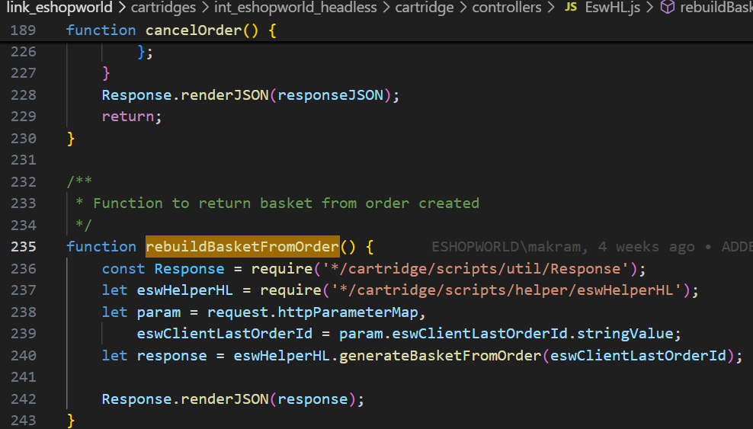

Explanation:

Input Parameter: eswClientLastOrderId (from request).
Helper Call: Uses generateBasketFromOrder method to reconstruct the basket.
Response: JSON response with reconstructed basket details.

2. Helper Function: generateBasketFromOrder(eswClientLastOrderId)
To generate a basket based on an existing order, typically used when the order was created but not finalized (e.g., failed, created, or new state).

Key Steps:

Fetch the Order:
Uses OrderMgr.getOrder(eswClientLastOrderId) to retrieve the order.
Validates if the order is in FAILED, CREATED, or NEW status.
Rebuild the Cart:
Calls eswHelper.rebuildCartUponBackFromESW(orderNo) to initiate a rebuild.
If the order status is CREATED, it is explicitly failed (OrderMgr.failOrder).
Extract Line Items:
Iterates over ProductLineItems and extracts productId, price, quantity.
Extract Coupons:
Calls getRetailerPromoCodes(order) to get coupon codes.
Create/Fetch Basket:
Uses BasketMgr.getCurrentOrNewBasket().
Return Payload:
Returns an object containing:
orderLineItems
basketId
couponCodes
basketItems
removeLineItems flag
Returned Object Format:
json
{
orderLineItems: { products: [...] },
basketId: "UUID",
couponCodes: [ { code: "PROMO123" }, ... ],
basketItems: [ { productId: "xyz", lineItemId: "uuid" }, ... ],
removeLineItems: true/false
}

3. Helper Function: getRetailerPromoCodes(order)

Extracts any coupon codes applied to the order.Checks if couponLineItems exist in the order and Loops through them and collects valid couponCode values.
Returns:
An array of objects like:
"couponCodes": [
{
"code": "Coupon Code"
}
]
4. Integration Instruction for Headless Implementation

To integrate this functionality into a headless environment, developers must invoke the EShopWorld-RebuildBasketFromOrder endpoint using an HTTP POST request. This endpoint requires the query parameter eswClientLastOrderId to identify the target order.
Example Endpoint:
SiteGenisis compatible Architecture: Post https://hostname/on/demandware.store/Sites- SiteGenesis-Site/en_US/EswHL- RebuildBasketFromOrder?eswClientLastOrderId=OrderID
SFRA compatible Architecture: Post https://hostname/on/demandware.store/Sites-RefArch- Site/en_US/EswRefArchHL- RebuildBasketFromOrder?eswClientLastOrderId=OrderID
These endpoint is essential for reconstructing the customer's basket based on a previously created order, typically used when returning from the ESW checkout flow
5. Conclusion
The above code changes are intended solely for back-end modifications.
Retailers are required to pass the Order ID when triggering the endpoint.
Any front-end related changes should be handled by retailers according to their specific customizations.

